Clayton DeSimone

Thesis/Capstone

Final Project

5/2/2024

Below is a list of all the updates that needed to take place for the HHAA website that my mom (Gayle Joslin - GJ) had prepared upon me taking up this task as my Capstone project. As I am now the designated maintainer of this website, I will provide continuous maintenance moving forward.

**Helena Hunters & Anglers**

**Website Updates**

KEY to this outline: GJ to DO soon but not now

**Items that have been accomplished are in GRAY**

**Text to be added is in Green**

**Brown indicates where changes are needed.**

**HOME**

* REMOVE: icons for Twitter(X) and Pinterest. LEAVE: Instagram, LinkedIn -- HHAA only has a Facebook acct
* Facebook page link takes one to the *manage page.*  Shouldn’t it take one to the Notification page???? Change the link.

\*\*Move Positions and Statements to the end of OUR IMPACT – below Wildlife Surveys

**POSITIONS & STATEMENTS NEW PAGE here with photo [Sleeping Giant]**

**Positions and Statements**

At HHAA, we believe that actions speak for themselves, so we have taken on several projects to follow through on our convictions. Some of those projects have been completed (Past Accomplishments), while others are works in progress (Our Impact, Current Events, HHAA News).

At the same time, HHAA often supports positions taken by other conservation groups recommending specific action (or avoidance of some action) to benefit wildlife and the natural resources that support them. Below are some of those positions.

* Public Land Transfer and Sale -opposition from National Sportsmen - Letter 2015-04-14 
* Colestrip Air Quality Permit 2012-09-19 HHAA Comment 
* Land and Water Conservation Fund Support-Sportsmans Groups 2011-07-08 
* OP-ED I-161 End outfitter sponsored out-of-state big game licenses-Posewitz 2010-10-21 
* CM Russell National W ildlife Refuge-Oil and Gas-Sporting Group Comment 2009-01-31

**ABOUT**

* Put in CAPS: HELENA HUNTERS & ANGLERS ASSOCIATION MISSION (which is then followed by “The Helena Hunters & Anglers Association is dedicated to: …”)
* Leave icons for Twitter, Instagram, LinkedIn, Pintrest -- HHAA only has a Facebook acct
* LINK Cinnabar logo and WELC logo to their websites:
  + <https://www.thecinnabarfoundation.org/>
  + <https://westernlaw.org/>
* HHAA Logo – needs to be changed wherever it occurs on the website since we have a new one: 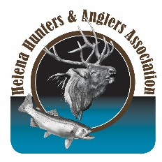https://helenahuntersandanglers.org/wp-content/uploads/2020/10/HHAA-logo.png

On the lower portion of the page, this “Become an HHAA Member” link does not work.

It needs to be linked to the BECOME A MEMBER page and/or CONTRIBUTE page:

* 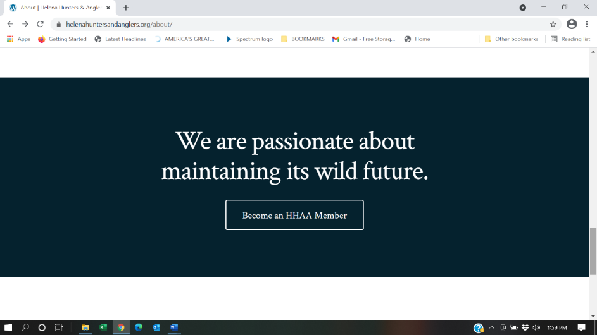

**OUR STORY**  - Change the order in which these pages are listed:

* About
* Our Story
* HHAA Board
* Contact HHAA
* Become a Member

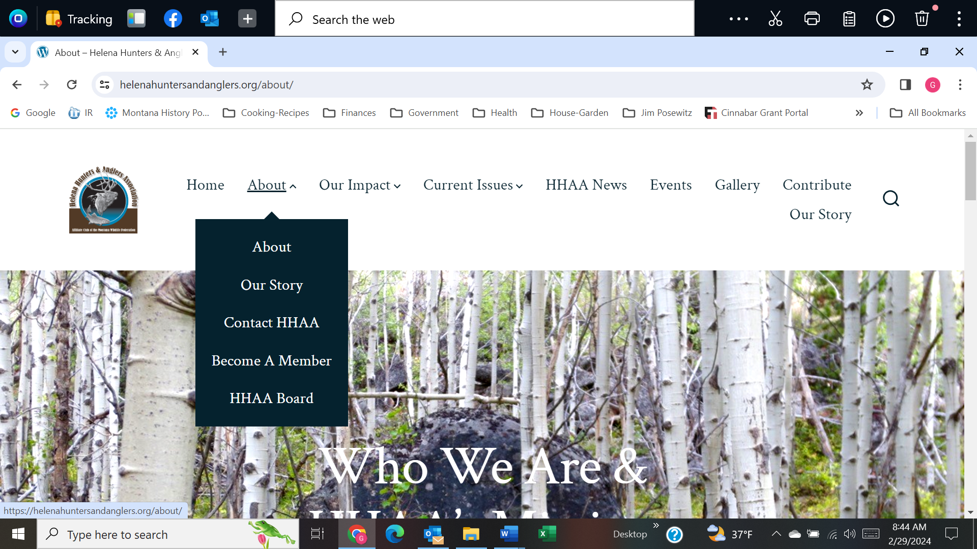

* **Our Story** occurs under the **ABOUT** page, but it also occurs by itself at the end of the pages as a separate page called OUR STORY, and this last page is duplication that should be deleted
* First paragraph under **Our Story** is OKAY, but the **HHAA Timeline** will have to be updated beyond 2022 (but okay for now – *GJ to DO*). There is software for displaying timelines that we’d like to use, but its too complicated for gayle, so using a link to a document now.
* Under “Our Founder” (Poz) a space is needed in this sentence after the period. ***expects of him or her as a hunter.”***That
* Remove underline from the space before the word “states”. The final line in Beyond Fair Chase states; ***“…it is the*** .Also, use a colon (:) and not a semi-colon after “states:”
* ~~last 40 years~~ instead say “last half century”
* Second paragraph about Jim Posewitz is OKAY, but the next section on his books … Jim’s Books – G has new Pdf [text wrapping alongside photo of books, where to get (email HHAA), and cost if purchased through HHAA.



* Next statement by Poz, reduce font size from 42.5 to 30 or less – whatever fits and looks good. “A society or culture is ultimately measured not by what it developes or consumes, but rather by what it has nurtured and preserved.”  
  ~ Jim Posewitz ~ Move the last quotation mark to after preserved. Currently the quotation mark is after Posewitz – remove that quote mark.
* POZ’S picture is squeezed vertically – needs to look normal
* On this page eventually, we will have a Tribute to Jim Posewitz… maybe by adding the word Tribute as a link after his dates (see above). This has yet to be written. Photos of Yellowstone river commemorative site would likely be used.
* HHAA Timeline Although this currently works, the intent is to also have a graphic timeline of more contemporary issues. There is software to do this, but too complicated for gayle, so linked to a pdf for now (which needs updating).

**HHAA BOARD 🡪 Meet our HHAA Board** List in following order:

* **Steve Platt**  New photo of Steve. 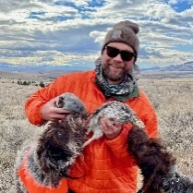 Narrative okay except delete “ , Interim Secretary” President~~, Interim Secretary~~
* **Rod Bullis** Change:~~Board Member~~ Vice President
* **Gary Ingman** Change: ~~Vice President,~~ Treasurer
* **Pete Christiansen** Secretary No photo or info yet, so just list his name and position
* **Gayle Joslin** Board Member Replace her write up/photo with the following 
* **Camie Westfall** Board Member No photo or info yet, so just list her name and position
* **Rick Henry** NEW entry: 
* **Nick Gevock** Board Member No photo or info yet, so just list his name and position
* **DELETE Charlie McCarthy, Jim Crichton, Steve McEvoy, Bill Orsello**

**CONTACT HHAA** All Okay

**BECOME A MEMBER**

* Become an HHAA Member. The link to “Download form” does not work. Here is the form to link to: v
* BECOME A MEMBER is the *same*  as the CONTRIBUTE page (several fixes needed on that page – see very bottom of this list of fixes)

The only way in which these pages differ right now is: after one clicks on the “BECOME A MEMBER” page, the subtitle is slightly different from the CONTRIBUTE page -- that is fine since BECOME A MEMBER is its own page. SEE the CONTRIBUTE PAGE (bottom of this document).

**B – OUR IMPACT -- OUR IMPACT** Links to WELC and Cinnabar logos

<https://westernlaw.org/>

<https://www.thecinnabarfoundation.org/>

The following is on the *main* **OUR IMPACT** page, but it is also on the **HUNTING** page, and needs to be removed from the HUNTING page.

Usually, no single individual, group, or organization, on their own, influences history. However, together and with focused leadership, wonderful accomplishments do occur. Helena Hunters and Anglers Association is proud to have stood on the shoulders of giants in our quest to preserve wildlands, wildlife, and our legacy of conservation – in our own “back yard.”

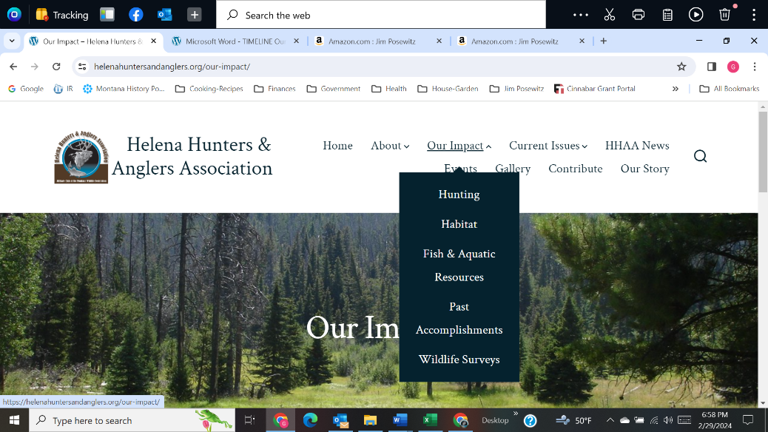**\*\*On dropdown Menu:**

**Insert “Wildlife” (new page) after “Hunting” and before “Habitat”**

**Change “Wildlife Surveys” on dropdown menu to: Wildlife & Habitat Surveys**

Add *“***Positions & Statements”** to bottom of the menu. Add a page for**Positions & Statements**at end of “HABITAT”

**B1 – HUNTING**

**B1a – Our Impact: Hunting**

* Remove text described above
* In Defense of Hunting by Joseph Bullington (Dec 2021) -- moved from HHAA News to Hunting

**B1b – Hunting Seasons** here is what is there now – keep this but go to “Add:”

### Hunting Seasons

Montana’s biennial hunting seasons define how, when, where, and specific sex and age class of animals that may be harvested by hunters.   HHAA weighs in on many proposals issued by the MFWP Commission.  The basis for hunting in North America, is the North American Model of Wildlife Conservation.

Add: Considerable comment foreshadowed release of the 2023 Montana Elk Plan. 

### Add: In November, 2023 MFWP released the **2023 Montana Statewide Elk Management Plan**

<https://fwp.mt.gov/conservation/wildlife-management/elk/elk-management-plan>

See MFWP for Hunting information:  Replace: <http://fwp.mt.gov/education/hunter/default.html>   With: <https://fwp.mt.gov/hunt>

**B1c – Shoulder Seasons** Replace “five” with “several” :

Elk Shoulder Seasons are a controversial topic.  Over the past ~~five~~ several years, HHAA has consistently commented on this “experiment” that was to have taken three years.  See attached commentary detailing HHAA position.

* [Bob Ream Comments on Elk Shoulder Seasons](https://helenahuntersandanglers.org/wp-content/uploads/2020/10/Comments-on-Elk-Shoulder-Seasons-Bob-Ream.pdf) All these Blue links are OKAY. Others may be added in future.
* [HHAA Comment August 10, 2015](https://helenahuntersandanglers.org/wp-content/uploads/2020/10/Elk-Shoulder-Seasons-2015-HHAA-comment.pdf)
* [HHAA Comment January 18, 2019](https://helenahuntersandanglers.org/wp-content/uploads/2020/10/Elk-Shoulder-Season-HHAA-Comments-1-18-2019.pdf)
* [HHAA Comment December 4, 2019](https://helenahuntersandanglers.org/wp-content/uploads/2020/10/Elk-Shoulder-Seasons-12-4-2019.pdf)
* [Montana Land Ownership, Elk Distribution, Hunt Districts and Private Lands Leased to Outfitters](https://helenahuntersandanglers.org/wp-content/uploads/2020/10/Montana-Land-Ownership-Elk-Distribution-Outfitting-Map.pdf)

**B1d – Mandatory Reporting**

* [Comment by HHAA to MFWP regarding Mandatory Reporting April 5, 2018](https://helenahuntersandanglers.org/wp-content/uploads/2020/10/Mandatory-Reporting-4-5-2018_Ingman-to-MacDonald.pdf)

**\*\*BB1 – WILDLIFE** newly inserted page thus the double BB for the outline

**BB1a – Bison Restoration**

**BB1b – Wildlife Reports/Information**

* Alter the following sentence:Check in to find the latest in wildlife research and issues of concern on species ranging from mountain goats to ~~wolves and~~ wolverine and mountain lions. Recent research and reports on various wildlife.
* **Smith and DeCesare - Mtn Goat – Cover pg** [Link the report to the cover page]
* <http://fwp.mt.gov/fishAndWildlife/diseasesAndResearch/research/default.html> <-- *replace this broken current link with these 3****:*** [***https://fwp.mt.gov/conservation/chronic-wasting-disease***](https://fwp.mt.gov/conservation/chronic-wasting-disease) *and delete this*
* [**https://fwp.mt.gov/conservation/chronic-wasting-disease**](https://fwp.mt.gov/conservation/chronic-wasting-disease)*and*
* [**https://fwp.mt.gov/conservation/diseases**](https://fwp.mt.gov/conservation/diseases)
* [Status of Montana’s Mountain Goats by Smith and DeCesare 2017](https://helenahuntersandanglers.org/wp-content/uploads/2020/10/Smith_and_DeCesare_MFWP_MountainGoat_Report_2017-highlighted.pdf)
* [Elkhorns and Hiding Cover 2019](http://fwp.mt.gov/fishAndWildlife/diseasesAndResearch/research/elk/elkhorn/default.html) *use this statement to connect to Lowrey etal. Rather than “Hiding without cover…” but that link works!* ”[Hiding Without Cover?  Defining Elk Security in a Beetle-Killed Forest](https://helenahuntersandanglers.org/wp-content/uploads/2020/10/Hiding-Without-Cover-2019.pdf)”
* [Garnet Mountain Lion Project](http://fwp.mt.gov/fwpDoc.html?id=50730) *fix link with this:*

*https://fwp.mt.gov/binaries/content/assets/fwp/conservation/wildlife-reports/mountain-lion/mtlionfinalreportwithcovers2011lowresolution1o*

* Reproductive Success of Elk Following Disturbance by Humans During Calving Season
* [Chronic wasting disease updates](https://fwp.mt.gov/conservation/chronic-wasting-disease) move to bottom under “Effects…”
* [Effects of Recreation on Rocky Mountain Wildlife](https://helenahuntersandanglers.org/wp-content/uploads/2024/04/Effects-of-Recreation-document.pdf)

**BB1c – from C5 – Sensitive, Threatened, and Endangered Species**

* **Wolverine -** A general description of wolverine, as well as diagnostic characteristics, species range, observations, migration, habitat, and ecological descriptions are provided in the Field Guide produced by Montana Natural Heritage. [Link to: <https://fieldguide.mt.gov/speciesDetail.aspx?elcode=AMAJF03010> ]

HHAA’s involvement in establishing the legal status of the wolverine is provided in Past Accomplishments [Link to Past Accomplishments – added ID attribute for wolverine section]

**BB1d – Recreation Impact References**

* [Effects of Recreation on Rocky Mountain Wildlife – Joslin & Youmans](https://helenahuntersandanglers.org/wp-content/uploads/2020/12/Effects-of-Recreation-on-Rocky-Mountain-Wildlife-Joslin-Youmans.pdf) Change Joslin & Youmans to Montana Chapter of The Wildlife Society
* Behavioral Responses of North American Elk to Recreational Activity Link to the statement [Naylor et al.\_elk-recreation\_JWM\_April09](https://helenahuntersandanglers.org/wp-content/uploads/2020/12/Naylor-et-al._elk-recreation_JWM_April09.pdf)
* Analyzing animal movement patterns in relation to human activity Link to the statement [Preisler\_et\_al-2013-Ecosphere-Analyzing Animal Movement](https://helenahuntersandanglers.org/wp-content/uploads/2020/12/Preisler_et_al-2013-Ecosphere-Analyzing-Animal-Movement.pdf)
* Scientist say mtn bikes negatively impact bears-Todd Wilkenson 2019-05-22 Link to the statement <https://mountainjournal.org/scientists-say-mountain-biking-negatively-impacts-bears>
* Shifting Values – Funhog Towns – Mountain Journal 2018-04-04 Link to the statement  <http://mountainjournal.org/the-rise-of-funhog-towns>

**BB1e – Wildlife Disease**

* See the latest news about CWD in Montana as well as information about the disease and ongoing surveillance efforts~~:~~. Link to statement  <http://fwp.mt.gov/cwd/>
* Learn how to properly obtain and submit harvested wildlife samples to test for CWD: Link to statement [http://fwp.mt.gov/conservation/chronic­-wasting-disease/get-your-animal-sampled](http://fwp.mt.gov/conservation/chronic-wasting-disease/get-your-animal-sampled)

**B2 – HABITAT** Color of “Habitat” needs to be white on the photo

#### **B2a -** **Big Game Security – the heart of HHAA advocacy**

* **From an ethical hunter’s standpoint, wildlife habitat, in all its seasonal forms must be maintained, and where necessary, enhanced. Habitat security and fair chase hunting practices ensure that ethical hunting opportunities are the norm across our landscape – now and in the future.**

#### (this is the 2nd statement) fix with narrative

* **Big Game Security has been a constant and pervasive concern for HHAA as we attempt to influence public land processes ranging from travel planning, forest management, and recreational developments.  As humanity expands, and alters landscapes, wildlife security has precariously declined.  This issue can be found at the heart of our work along the Continental Divide, in Inventoried Roadless Areas, proposed Wilderness, and the Elkhorn Mountains Wildlife Management Unit.**
  + [**Big Game Security**](https://helenahuntersandanglers.org/current-issues/)needs to be **linked** to “OUR IMPACT-Past Accomplishments” where the Amendment is discussed
* Add: **Scientific research that defines wildlife security and details its importance, as well as many of the factors contributing to denigration of security, is provided in documents below:**
  + [Elkhorn Mountains Wildlife Management Unit and Hiding Cover (2019](http://fwp.mt.gov/fishAndWildlife/diseasesAndResearch/research/elk/elkhorn/default.html)) <https://wildlife.onlinelibrary.wiley.com/doi/full/10.1002/jwmg.21781>
  + Outdoor Recreation and Elk: A Colorado Case Study [*https://storymaps.arcgis.com/stories/a0a8b0e3d65d4156886cd7e0cc5cee7f*](https://storymaps.arcgis.com/stories/a0a8b0e3d65d4156886cd7e0cc5cee7f)
  + Elk herd population plummets as human use grows <https://www.skyhinews.com/news/elk-herd-population-plummets-in-aspen-vail-areas-as-human-use-grows/>
  + Elk vs. Trails – conflicts over public  *)* <https://www.denverpost.com/2019/02/24/steamboat-springs-trails-elk-routt-forest/>
  + **Effects of Roads on Elk: Implications for Management in Forested Ecosystems** *Link this statement to this link (article available =* )[**https://www.fs.usda.gov/research/treesearch/24797**](https://www.fs.usda.gov/research/treesearch/24797)
  + Security areas for maintaining elk on publicly accessible lands during archery and rifle hunting seasons *Link this statement to this link (article available =*  *)* https://www.jstor.org/stable/26607564
  + Behavioral Responses of North American Elk to Recreational Activity *Link this statement to this link (article available =*  *)* [*https://www.jstor.org/stable/40208532*](https://www.jstor.org/stable/40208532)
  + Effects of Hunter Access and Habitat Security on Elk Habitat Selection *Link this statement to this link (article available =*  *)* [*https://wildlife.onlinelibrary.wiley.com/doi/abs/10.1002/jwmg.491*](https://wildlife.onlinelibrary.wiley.com/doi/abs/10.1002/jwmg.491)

**B2b – Inventoried Roadless Areas ~~& Continental Divide~~** *fix:*

**Inventoried Roadless Areas provide islands of reprieve for wildlife within otherwise disturbed expanses of National Forest lands surrounding the Helena area ~~are many~~. These IRAs provide the heart of remaining wildlife habitat on our landscapes. Whether these IRAs receive Wilderness designation or not, HHAA is working to prevent further fragmentation and to preserve their integrity for wildlife into the future.**

**Helena Hunters and Anglers has initiated a monitoring process to address the status of IRAs and provide a “report card” of their condition to the public as well as the Helena-Lewis and Clark National Forest. To see what is involved in monitoring the IRAs, see our Current Issues page. [Link to Current Issues: https://helenahuntersandanglers.org/current-issues/]**

**Individual IRAs that occur within the Helena area and HHAA’s involvement in their establishment and welfare are provided here.**

~~The following Inventoried Roadless Areas (IRAs) collectively, provide links in a fragile chain that connects the Northern Continental Divide Ecosystem with the Yellowstone Ecosystem. Wildlife movement between ecosystems appears to be occurring. A deceased grizzly [Link to Mt Haggin dead bear photo] found on the Mount Haggin WMA south of Interstate 90 was genotyped as being from the Northern Continental Divide Ecosystem. Movement information of other large carnivores suggests that such ecosystem interaction is likely being achieved.~~

~~The Montana Chapter of The Wildlife Society [Link to MT Ch Wildlands testimony] canvassed wildlife biologists across the state regarding recommendations for Inventoried Roadless Areas and submitted comment to Congress from 1981 to 1994. For IRAs in the Helena vicinity, wildlife biologist support commentary is provided below.~~

* [**Recommendations for Inventoried Roadless Areas -2016**](https://helenahuntersandanglers.org/wp-content/uploads/2020/10/RECOMMENDATIONS-FOR-INVENTORIED-ROADLESS-AREAS-2016.pdf)
* [**MAP Important Roadless Corridors for Wildlife**](https://helenahuntersandanglers.org/wp-content/uploads/2020/10/MAP-Important-Roadless-Corridors-for-Wildlife.pdf)
* [**RARE and RARE II FS-650**](https://helenahuntersandanglers.org/wp-content/uploads/2020/10/RARE-and-RARE-II-FS-650.pdf)
* **Nevada Mountain IRA**
  + [**Wilderness Testimony July 1983 supporting Nevada Mountain**](https://helenahuntersandanglers.org/wp-content/uploads/2020/10/Testimony-supporting-Nevada-Mountain-Wilderness-Gary-Ingman-July-1983.pdf)
  + [**MAP of Wildlands of the Northern Continental Divide**](https://helenahuntersandanglers.org/wp-content/uploads/2020/10/MAP-Wildlands-of-the-Divide.pdf) **-- Nevada Mountain** Insert “Northern Continental” before the word “Divide” and add “ – Nevada Mountain” after “Divide”fix so it reads: **“MAP of Wildlands of the Northern Continental Divide – Nevada Mountain”**
  + [**NEVADA MOUNTAIN IRA supporting comment**](https://helenahuntersandanglers.org/wp-content/uploads/2020/10/Nevada-Mountain-Support-by-HHAA-in-Forest-Plan-May-25-2016.pdf) **from HHAA**
  + [**OpEd July 26, 2018, Gary Ingman, Expand the Southern Crown**](https://helenahuntersandanglers.org/wp-content/uploads/2020/10/Op-Ed-Expanding-the-Crown-Nevada-Mtn-2018-07-26-Missoulian.pdf)
* **Lazyman-Black Mountain IRA**

* + **[LAZYMAN-BLACK MTN IRA support commentary](https://helenahuntersandanglers.org/wp-content/uploads/2020/10/LAZYMAN-BLACK-MTN-IRA-support-commentary.pdf" \t "_blank)** [replace]
  + [**Colorado-Telegraph trail 5-22-2017-field tour**](https://helenahuntersandanglers.org/wp-content/uploads/2020/10/Colorado-telegraph-trail-5-22-2017-PDF.pdf)
  + [**MAP Lazyman IRA & Jericho IRA**](https://helenahuntersandanglers.org/wp-content/uploads/2020/10/MAP-Lazyman-IRA-Jericho-IRA.pdf)
  + [**MAP of Wildlands of the Southern Continental Divide-~~South~~ Lazyman**](https://helenahuntersandanglers.org/wp-content/uploads/2020/10/MAP-Wildlands-of-the-Divide-South.pdf)Insert the words “Southern Continental” before the word “Divide”. Remove “South”
  + [**Illegal Camp Removed – HHAA thanks FS**](https://helenahuntersandanglers.org/wp-content/uploads/2020/10/Illegal-Camp-Removed-HHAA-thanks-FS.pdf)
* **Electric Peak IRA**
  + [**ELECTRIC PEAK IRA support commentary**](https://helenahuntersandanglers.org/wp-content/uploads/2020/10/ELECTRIC-PEAK-IRA-support-commentary.pdf)[replace]
  + [**MAP Wildlands of the Divide-South**](https://helenahuntersandanglers.org/wp-content/uploads/2020/10/MAP-Wildlands-of-the-Divide-South-1.pdf)Insert the words “Southern Continental” before the word “Divide”. Replace “South” with “Electric Peak” so it reads [**MAP Wildlands of the Southern Continental Divide-Electric**](https://helenahuntersandanglers.org/wp-content/uploads/2020/10/MAP-Wildlands-of-the-Divide-South-1.pdf) **Peak**
* **Jericho Mountain IRA**

* + **[MAP Wildlands of the Divide-South Lazyman](https://helenahuntersandanglers.org/wp-content/uploads/2020/10/MAP-Wildlands-of-the-Divide-South-2.pdf" \t "_blank)** Insert the words **“Southern Continental”** before the word “Divide”. Exchange “South” with Lazyman so it reads **MAP: Wildlands of the Southern Continental Divide – South Lazyman**
  + [**MAP Lazyman IRA & Jericho IRA**](https://helenahuntersandanglers.org/wp-content/uploads/2020/10/MAP-Lazyman-IRA-Jericho-IRA-1.pdf)
  + [**JERICHO MOUNTAIN IRA support commentary**](https://helenahuntersandanglers.org/wp-content/uploads/2020/10/JERICHO-MOUNTAIN-IRA-support-commentary.pdf)[replace]
* **Other IRAs**
  + [**ANACONDA HILL IRA support commentary**](https://helenahuntersandanglers.org/wp-content/uploads/2020/10/ANACONDA-HILL-IRA-support-commentary.pdf)[replace]
  + [**Divide Wilderness Eval-Sweeney2-2016**](https://helenahuntersandanglers.org/wp-content/uploads/2020/10/Divide-Wilderness-Eval-Sweeney2-2016.pdf)
  + [**SLEEPING GIANT-BEARTOOTH support commentary**](https://helenahuntersandanglers.org/wp-content/uploads/2020/10/SLEEPING-GIANT-BEARTOOTH-support-commentary.pdf)[replace]
  + [**SPECIMEN CREEK IRA support commentary**](https://helenahuntersandanglers.org/wp-content/uploads/2020/10/SPECIMEN-CREEK-IRA-support-commentary.pdf)[replace]
  + [**SWEENEY CREEK IRA support commentary**](https://helenahuntersandanglers.org/wp-content/uploads/2020/10/SWEENEY-CREEK-IRA-support-commentary.pdf)[replace]
  + [**MAP Wildlands of the Divide**](https://helenahuntersandanglers.org/wp-content/uploads/2020/10/MAP-Wildlands-of-the-Divide-1.pdf)Insert the words “Northern Continental” before the word “Divide” so it reads: **“MAP: Wildlands of the Northern Continental Divide”**

**B2c – Elkhorn Wildlife Management Unit**

* [**Timeline – Elkhorn Wildlife Management Unit**](https://helenahuntersandanglers.org/wp-content/uploads/2020/10/Timeline-Elkhorn-Wildlife-Management-Unit.pdf) **replace with new version pdf dated 4-26-2024**
* 1984 Elkhorn Mountains Wildlife Management Unit: past present and future of a Forest Service planning prototype. Frank C. Crowley, University of Montana <https://scholarworks.umt.edu/cgi/viewcontent.cgi?article=7582&context=etd>
* Elkhorn Mountains Elk Project Final Report | 2015–2018 <https://fwp.mt.gov/binaries/content/assets/fwp/conservation/wildlife-reports/elk/elkhornmtnselkproject_finalreport.pdf>

**B2d – Wildlife Management Areas**

Edit each WMA as follows: **~~For m~~ Maps, plan, and further details ~~go to MFWP:~~  [Link to** <https://myfwp.mt.gov/fwpPub/landsMgmt/siteDetail.action?lmsId=39753390>

**B2e – Wildlife Connectivity & Continental Divide**

PHOTO: Grizzly tracks – photo by Gary Ingman [CDT Griz Tracks 04192024]

Living on the edge of the Continental Divide, we at Helena Hunters and Anglers are privileged to have observed many of North America’s most iconic animals use this natural geographic linkage corridor – those uncommon creatures at the top of the food chain that can’t be made ordinary, safe, or convenient. Grizzly bear, wolverine, mountain lions, wolves, and lynx move through the landscape using a patchwork of wildland habitat that still exists along the Continental Divide. This major thoroughfare connects distant ecosystems because wild country, often in the form of existing and proposed Wilderness and Inventoried Roadless Areas, provide the security and habitat necessary to sustain these relatively rare and magnificent creatures.

So, why is connectivity for wildlife important? [Link to **McKelvey, Schwartz and Ruggiero]** Research demonstrates thatactivities that simultaneously decrease habitat quality and connectivity are particularly destructive to wildlife populations. Which is why Lewis and Clark County is to be commended for their foresight in adopting a ***“Resolution to Protect and Promote the Conservation of Wildlife Habitat and Corridors On the Continental Divide.”*** [Link to the Resolution]HHAA drafted the resolution and testified in its support [Link to HHAA testimony] along with conservation groups and locals. [Link to IR article].

**\*\*The quote from McKelvety, Schwartz and Ruggiero Needs formatting – change font type** (Cambria Math) **for the quote, then indent and reduce font of authors as indicated below** (Footlight MT Light, italics)**:**

“… **for what species does landscape level connectivity really matter? It matters most for organisms with extremely large home ranges relative to the habitat patch sizes, and relatively low birth rates.”**

*McKelvey, Schwartz, and Ruggiero -- USDA Forest Service, Rocky Mountain Research Station*

A multitude of activities [Link to L&C CO map of wildlife corridors] have and are occurring along the Continental Divide that not only diminish the Divide’s many types of wildlife habitats, but also compromise its ability to accommodate wildlife movement and genetic flow between ecosystems. [Link to Partial List of Continental Divide Impacts]

Helena Hunters and Anglers resisted development of a military training facility on the crest of MacDonald Pass. [Link to HCTV Interview] A biathlon course was slated to be constructed in this one-mile-wide portion of the Divide, which is also among the narrowest constrictions of public land in the roughly 600 mile stretch of the Divide from the Canadian border to the Yellowstone ecosystem. HHAA, along with eight other appellants, filed an administrative appeal [Link to Administrative Appeal] to the Forest Service decision to allow the project to proceed. Because the Helena National Forest denied the appeal, a complaint was filed in federal court [Link to Complaint] on behalf of four conservation organizations, including HHAA. On July 29, 2009, a federal court judge put a halt to construction of the biathlon course near MacDonald Pass west of Helena. [Link to IR-Judge halts biathlon]

Through the public participation process, HHAA has attempted to influence dozens of public land projects – all of which contribute to landscape fragmentation. Select commentary on a variety of projects including timber sales, highway construction, mining, and recreational impacts, to cite just a few, are provided for an historical record, and may once again be useful in the future – because history tends to repeat itself.

For decades, HHAA has been advocating for a Continental Divide that can serve the needs of wildlife for movement, genetic linkage, and habitat, at both the project and landscape level. We will continue to do so, and we would welcome your participation.

* Hazard Tree Project
* Rimini Road
* Telegraph Vegetation Project scoping

**B3 – FISH & AQUATIC RESOURCES CHANGE COLOR OF TITLE over picture of Poz fishing to black or Dark Blue**

**Change out the 2nd photo (same one) of Poz fishing with Lynn holding fish [Gallery DSC09207]**

**(this Subject needs a lot of work – in the future)**

* **Fix the link to** [Native Trout Management](file:///C:\Users\Gayle\Documents\HHAA\WEBSITE%202020-04-15\1%20Edits\Native%20Trout%20Management) **with** [**https://fwp.mt.gov/fish**](https://fwp.mt.gov/fish)
* **Fix the link to** [Invasive **Aquatic** Species](http://fwp.mt.gov/fishAndWildlife/species/ais/prevention.html) <https://fwp.mt.gov/conservation/aquatic-invasive-species/about>

**B4 – PAST ACCOMPLISHMENTS** (Policy/ Litigation) – brief text will exist but provide legal documents here - refer back to OUR IMPACT/Wildlife & HabitatPut articles in this (order)

* **Wolverine Status (1)**
* **Tenmile-South Helena Project [7-1-2020] (2)** [currently is a Page, needs to become a list item]
* **Divide Travel Plan intervention (3)**
* **Big Game Security Amendment [10-17-2015] (4)**
* **Bear Hair Snagging 2009-2012**
* **Wildlife Connectivity – MacDonald Pass Biathlon Challenge (5)**
* **MT Fish & Wildlife Conservation Trust (6)**
* **1986 Citizens Initiative for Helena Forest Plan (7)**

**Bear Hair snagging -- Add these photos in addition to the Chessman Grizzly photo already there: citizen science bear hair- platt; 2010 bear detections; 09-0818 Joslin Corral; Joslin 07-1410-18**

**fix this “Invalid content” (screenshot)**

**Subtitle: Grizzly bear observed in the Chessman Reservoir area of the Tenmile drainage.**

**Remove excess white space before griz photo**

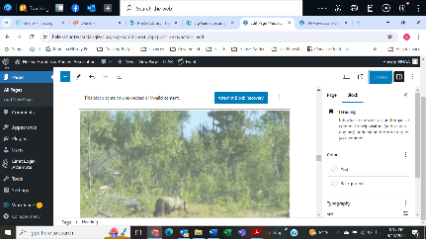

**Wildlife Connectivity – MacDonald Pass Biathlon Challenge** Transfer caused photos to morph into a vertical rather than horizontal presentation that required research and trial & error but resolved.

### **1986 Citizens Initiative for Helena Forest Plan**

Members of HHAA were also members of the [Helena Forest Conservation Coalition](https://www.helenahuntersandanglers.org/s/HFCC-History-1982-1991-Noel-Rosetta-1991-07-20.pdf) (HFCC) back in 1982, that helped shape the 1986 Forest Plan.  Forty years later, we are still engaged. *Fix broken link by connecting to:*

* **Tenmile-South Helena Project \*\***Move this page from **CURRENT ISSUES**
* **Wolverine Management**  After the Krebs reference add the following text:

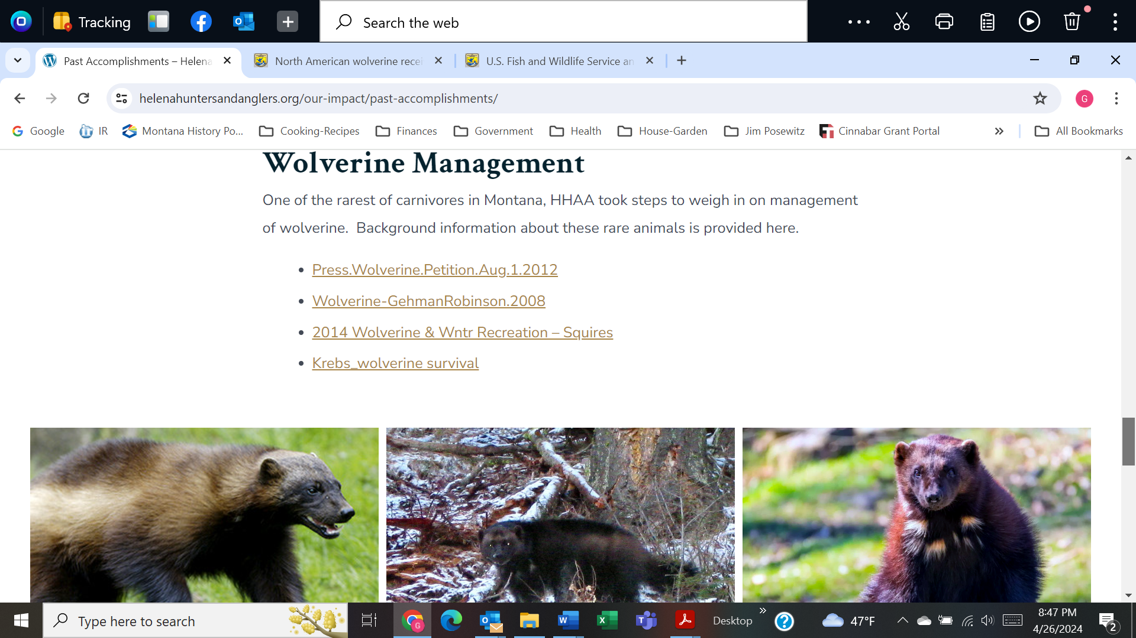

Although wolverine received *threatened* [Link to <https://www.fws.gov/question-answer/us-fish-and-wildlife-service-announces-final-rule-list-north-american-wolverine> ]

status under the Endangered Species Act in November 2023, the U.S. Fish and Wildlife Service also sought public comment on the 4(d) rule which exempts take related to research activities, take incidental to lawful trapping for other species, and take resulting from forest management activities associated with wildfire risk reduction in the contiguous U.S.  A decision on that rule is still pending as of May 2024.

Helena Hunters and Anglers Association provided comment (Link to HHAA comment on wolverine] on the wolverine 4(d) rule and was also represented in comments prepared by the Western Environmental Law Center. [Link to Comments.Interim.4.d.Rule.January.19.2024]

**B5 – WILDLIFE SURVEYS GJ IS WORKING ON THIS**

## Wildlife ~~Surveys~~/Volunteer

~~Wildlife study in the field will start later this winter, involving track surveys and observational data to continue wildlife research along the Continental Divide and the Helena area.~~

~~Public land~~ ~~m~~Monitoring of public land travel plan implementation and violations, as well as  ~~and~~ conditions in Roadless Areas, and across the National Forest and BLM lands are ongoing – and you are invited to help out!~~and may be expanded if there is public interest~~.

As oOpportunities arise for people to participate ~~public involvedment~~ in wildlife surveys, HHAA will ~~be~~ post~~ed~~ those events on ~~HHAA~~ our website under HHAA News as well as under ~~HABITAT~~OUR IMPACT: Wildlife Surveys~~-Volunteer~~. ~~For more information on posted events,~~ Get involved! Ffill out the [Contact Us page](https://helenahuntersandanglers.org/about/contact-hhaa/).

* Wildlife Field Surveys
* Forest Monitoring – *Adopt an Inventoried Roadless Area!* HHAA will train you to collect natural resource information about your favorite place to assure that it remains *WILD*! Check out the IRA Monitoring procedure in Current Issues. [Link back to IRA section in Current Issues]
* Montana Fish, Wildlife and Parks Wildlife Research – possibilities may arise to assist as happened with the **Bear Hair Snagging Project from 2008 through 2012** [Link back to Bear Hair in to Past Accomplishments]

**Check out Montana’s Species of Interest** Link to: [**https://fwp.mt.gov/conservation/species-of-interest**](https://fwp.mt.gov/conservation/species-of-interest)

**B6 – POSITIONS & STATEMENTS Move this NEW PAGE to the end of: ABOUT US -- with photo [Sleeping Giant]**

At HHAA, we believe that actions speak for themselves, so we have taken on several projects to follow through on our convictions. Some of those projects have been completed (Past Accomplishments), while others are works in progress (Our Impact, Current Events, HHAA News).

At the same time, HHAA often supports positions taken by other conservation groups recommending specific action (or avoidance of some action) to benefit wildlife and the natural resources that support them. Below are some of those positions.

* Public Land Transfer and Sale -opposition from National Sportsmen - Letter 2015-04-14 
* Colestrip Air Quality Permit 2012-09-19 HHAA Comment 
* Land and Water Conservation Fund Support-Sportsmans Groups 2011-07-08 
* OP-ED I-161 End outfitter sponsored out-of-state big game licenses-Posewitz 2010-10-21 
* CM Russell National W ildlife Refuge-Oil and Gas-Sporting Group Comment 2009-01-31

**C – CURRENT ISSUES**

\*\*Add IRAs, Move TSH to Past Acmplsh, Travel Mgmt New pg with subunits: Divide a nd Blkft, Forest Plan is ok, move Amendment to Past Accomplishments, Wildland Fire ok but add Climate Change, Wildlife Issues move to Wildlife, New Pg Sens/Threat/Endgrd, New Pg MT Legisl 2025 (hide for later info).

Photographs for Covers for most of above – adjustments to sizing. WordPress doesn’t allow much creativity.

Fix caption size via code under Leopold quote.

***Tenmile South Helena Project*** And, HHAA also endorses clearing on public **lands** within100 yards of private land (called private land buffers).

* + Move from Current Issues to Past Accomplishments under “OUR IMPACT” currently has its own page, but content was transferred as one of the items in the list included in PAST ACCOMPLISHMENTS.
  + Within TSH Proj - Move section entitled Recreation Impact References to OUR IMPACT – WILDLIFE after “Wildlife Reports/Information”
  + Move Wildlife Issues and Wildlife Disease from Current Issues to OUR IMPACT – Wildlife (NEW PAGE) under Wildlife Reports/Information
* …challenged the [Tenmile-South Helena Forest Project (TSH)](https://helenahuntersandanglers.org/wp-content/uploads/2020/10/Map-Ten-Mile-SHP.png) (map).

One has to adjust the screen view [Control, scroll] to read the dropdown boxes otherwise they are too long for the screen.

~~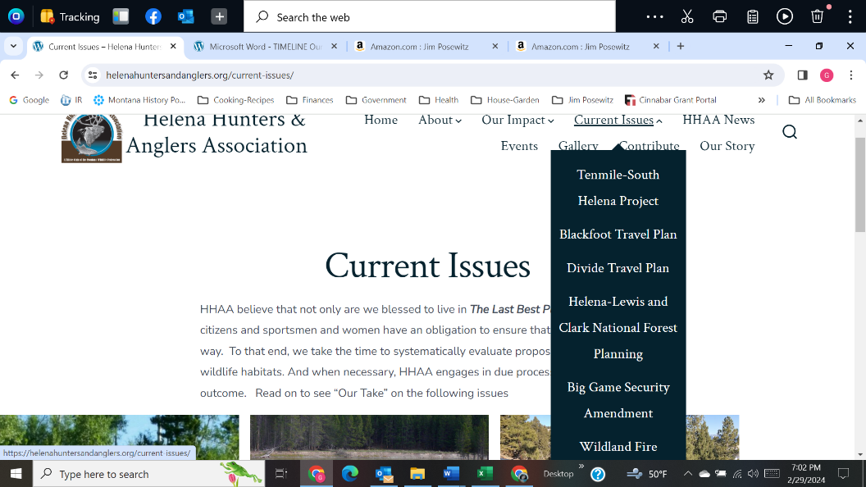~~Dropdown menu changed from this to…

This:

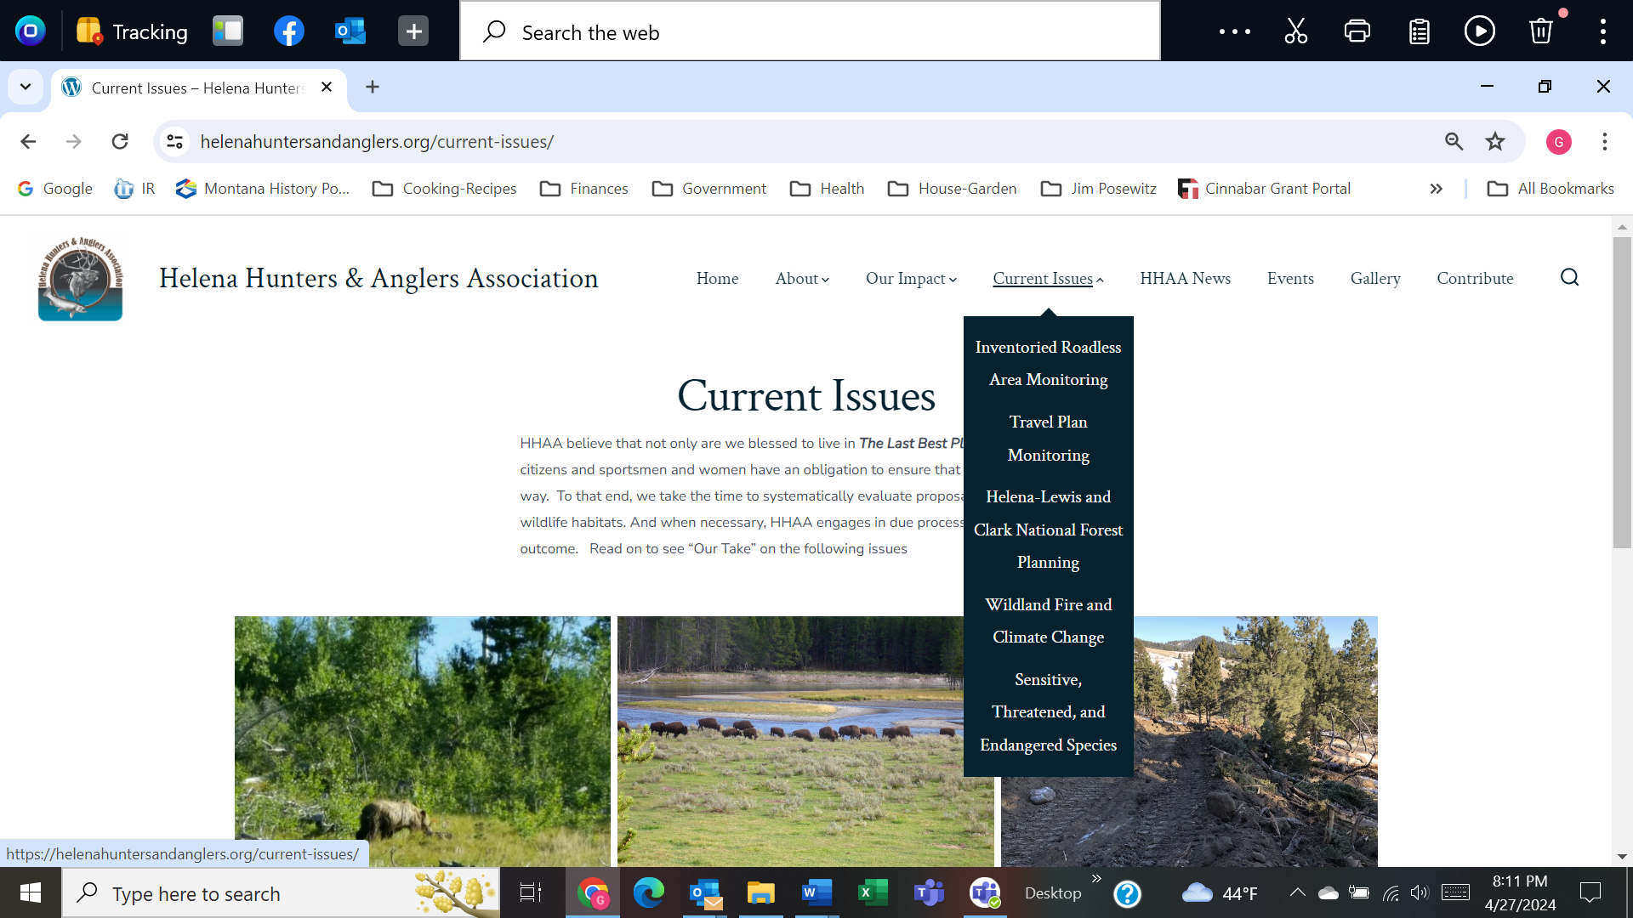

**C1 – INVENTORIED ROADLESS AREA MONITORING *new refer back to OUR IMPACT/Habitat***

**CURRENT ISSUES needs new pages: IRA MONITORING, TRAVEL PLAN MONITORING (with subunit for Divide and Blackfoot), SENSITIVE/THREATENED /ENDANGERED SPP, 2025 MT LEGISLATURE**

**Process for Monitoring IRAs – field personnel armed with mapping technology (Avenza, OnX), and geocode base maps, enter an area … … …**

* **Example of what we have discovered when keeping track of what is going on in the landscape:** Photos of illegal road constructed in March 2020 to the Lazyman IRA. This road, which the Forest Service said is a FEATURE, not a road, is 22’ wide and extends approximately one-half mile along and up to the IRA boundary.
* **Illegal Trails Report – Lazyman IRA – brief overview then post map and report**

**C2 –TRAVEL PLAN MONITORING \*\***Make a new Super Heading with Divide TP and Blkft TP under it

**C2a – Divide Travel Plan** exists

**C2b – Blackfoot Travel Plan** exists

**C3 –FOREST PLANNING- HLCNF** exists but need expansion with HHAA lawsuit

**C4 – WILDLAND FIRE and** CLIMATE CHANGE Wildland Fire exists (in future may create additional page for Timber Sales)

**C5 – SENSITIVE, THREATENED and ENDANGERED SPECIES** wolverine here

* Wolverine – See discussion of wolverine legal status in Past Accomplishments [Link to Past Accomplishments – Wolverine]

**C6 – 2025 MONTANA LEGISLATURE** [Make this page available, but hide it until we have something to show]

**D – HHAA NEWS *[reorder with most recent at top; NEW news items]*** *{Can we add items from deep history into the list so they show up when they happened years ago???}*

* Remove: “Leave a Reply” at the end of each of these articles: *went into Comments Area Wrapper , looked for global way to accomplish, but there wasn’t one. So went into the GO theme file to edit.*
* Welcome to Helena Hunters & Anglers Association – can we repost this so it is always at the top =🡺 or put a “sticky” on it so it stays at the top? (Its currently at the bottom) (1)
  + HHAA ~~has been~~ was part of the Montana Fish and Wildlife Conservation Trust’s citizen advisory board for xx years ~~since~~ from its inception until 2020. Thank you Bill Orsello!
  + 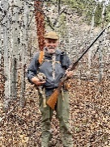
* Letter from the President (2) Minor edits: 1) remove date – this can be timeless, 2) remove “new” from the last sentence: Please take your time to look over our ~~new~~ website and consider joining our group.
* Montana Matters Outdoor Youth Experience – add in photos and text of event
* HHAA is part of a diverse group [ <https://meic.org/press-release-montana-organizations-and-businesses-petition-public-service-commission-to-consider-climate-costs-in-utility-regulation/> ] of more than 40 Montana organizations and businesses that submitted a petition to the Montana Public Service regulation Commission (PSC) to request that it adopt rules requiring consideration of climate change in its of Montana gas and electric utilities. (3a)
  + Petitioners assert that the PSC has a most consequential role in the future of Montana <https://dailymontanan.com/2024/02/28/40-orgs-businesses-to-public-service-commission-consider-climate-in-utility-regulation/> . Frank Szollosi, with the Montana Wildlife Federation, said Public Service Commissioners and all elected officials need to “recognize the intergenerational justice component” of public policy on climate change and their moral imperative to act for future generations.
  + In support of the petition, HHAA member Gayle Joslin provided testimony on behalf of Montana wildlife. <https://www.dropbox.com/scl/fi/h4qjc8awitoym4dpbhyrz/Youtube-HHAA-PSC-remarks.mp4?rlkey=fhs2r8elyvvihbvywl2v7481r&dl=0>
* In Defense of Hunting (Dec 2021) (move to HUNTING under OUR IMPACT )
* Montanans Intervene in Lawsuit Attacking State Management of Elk (June 2022) (5)
* North American wolverine receives federal protection as a threatened species under the Endangered Species Act (Nov 2023) <https://www.fws.gov/press-release/2023-11/north-american-wolverine-receives-federal-protection-threatened-species-under> (3b)

# Wolverines listed as “threatened” under Endangered Species Act after 20-year conservation effort [How to post News articles?] <https://westernlaw.org/wolverines-listed-as-threatened-under-endangered-species-act-after-20-year-conservation-effort/>

* Court again forces feds to reconsider wolverine protections, this time using science (2022) (4)
* Helena Hunters move to defend the Forest Service’s Divide Travel Plan (2022) (6)
  + For immediate release[add space] May 24, 2022 ~~Contacts:Steve Platt 406.202.2457 splatt4570@gmail.comDoug Powell 406.431.3554 wildowork2019@gmail.comGayle Joslin 406.449.2795 joznpoz@bresnan.net~~ Today, the Helena Hunters and Anglers Association (Helena Hunters) filed a motion to [add space] intervene on behalf […]
* Support for Wild Bison in Montana (May 2021) (7)

## REMOVE: [A response to Governor Gianforte’s direction to FWP in 2021 to forgo defense of public instream flow water rights in key fisheries](https://helenahuntersandanglers.org/a-response-to-governor-gianfortes-direction-to-fwp-in-2021-to-forgo-defense-of-public-instream-flow-water-rights-in-key-fisheries/)

* ~~620 South 3 rd StreetHamilton, MT 59840(406) 363-5719clanagher@q.comApril 14, 2022 Governor Greg GianforteOffice of the GovernorP.O Box 200801Helena, Mt 59620-0801~~ Dear Governor Gianforte, We are retired Montana fishery professionals who […]
* Montana Outdoor Hall of Fame – **HHAA Members** (8) Leave the MOHOF logo as is. Delete: Not sure we can edit the following (CJD did edit)

By [admin](https://helenahuntersandanglers.org/author/admin/) [Post dateDecember 3, 2020](https://helenahuntersandanglers.org/2020-montana-outdoor-hall-of-fame/) [No Commentson 2020 Montana Outdoor Hall of Fame](https://helenahuntersandanglers.org/2020-montana-outdoor-hall-of-fame/#respond)

* + delete everything else below it (all about GJ’s induction) and replace with the following:
    - Jim Posewitz, founder of Helena Hunters and Anglers Association, was inducted into the Montana Outdoor Hall of Fame in 2016 <https://mtoutdoorhalloffame.org/wp-content/uploads/2019/11/Jim-Posewitz.pdf>
    - Gayle Joslin – 2020 Inductee <https://mtoutdoorhalloffame.org/wp-content/uploads/2021/03/Joslin.png>

Montana Matters Outdoor Youth Experience - HHAA will be one of several sponsors of this event for kids at the Lewis & Clark County Fairgrounds on April 13 from 10 a.m. to 3 p.m. FREE TO ATTEND <https://montanayouthoutdoors.org/>

**E – EVENTS Re-establish this page and come up with a safer plug-in for our Calender**

**CALENDAR is functional.** *ADD:*

* **HHAA monthly meeting at Montana Wild,** 2668 Broadwater Ave, Helena, MT 59602 **on April 10, May 8, Sep 11, Oct 9, Nov 13, Dec 11 (2024)**
* **Montana Matters Youth Outdoor Experience LOCATION: Lewis & Clark Co Fairgrounds, Multi Purpose Building 98 West Custer Avenue, Helena, MT April 13 10am – 3pm FREE TO ATTEND** [**https://montanayouthoutdoors.org/**](https://montanayouthoutdoors.org/)

**F – GALLERY** Contact us for permission to use photos [button]

* Wildlife
* Hunting, Angling, & Recreating
* Landscapes

**CONTRIBUTE** 🡪 “Become An HHAA Member & Contributor”

## Membership costs for Student, Individual, Family upped to $15/$25/$40.

## 

## Download form doesn’t work. New form attached.

## 

NOTES FOR GJ:

* Now is the time to consider working on NEWS articles (blog) and coordinate with our Facebook page.
  + Most recent issues up front
    - Lawsuit on TSH (7)
    - Lawsuit on HLCNF Plan (4)
    - Intervenor lawsuit on behalf of HLCNF travel plan (5)
    - Lawsuit against UPOM (3)
    - Lawsuit on wolverine – newest info as of 2024 (2)
    - Inventoried Roadless Areas - Illegal Trails Project (6)
    - Inventoried Roadless Area Monitoring (2024) (1)
* Current Issues:  Add Inventoried Roadless Area – Illegal Trails Report
* HHAA News:
  + Letter from the President – Steve Platt’s letter – edits listed above
  + Update the Montana Outdoor Hall of Fame info.
    - List HHAA members (Posewitz, Joslin) – reduce write up of each
  + HHAA’s letter to the editor supporting Montana’s Constitution
* Payment platform leave as *PayPal* for now rather than Donor Box (as per Kathryn’s recommendation): PayPal has become quite partisan and has been blocking some websites lately claiming they are providing misinformation.  If you want more information about founder Peter Thiel, read on.  Peter Andreas Thiel is a German-American billionaire entrepreneur, venture capitalist, and political activist (Republican). A co-founder of PayPal, Palantir Technologies, and Founders Fund, he was the first outside investor in Facebook.  Mother Jones article about Thiel: <https://www.motherjones.com/politics/2022/10/jd-vance-blake-masters-peter-thiel-and-their-anti-big-tech-hypocrisy/>
* HHAA needs to work on Position Statements – what we have out there right now aren’t position statements, but rather letters we’ve sent on some topics – as place holders while we work on website.

**2024 Clayton DeSimone, Computer Programmer – taking Kathryn Kern’s place permanently (health issues). HHAA voted (3/13/2024) to retain Clayton for website maintenance.**

* Update/maintains safety features; block hacking attempts
* Formatting; new Page creation
* Missing/or stranded links
* Payment/donation links (Membership)
* Editing pages
* Replacing logos
* Coding where necessary when WordPress format is limited
* Research potential new software features
* Teaching HHAA members to make simple edits